|  |  |  |
| --- | --- | --- |
| **Department of Gender, Youth, Sports and Social Services** | | |
|  | **REPORT ON NYERI COUNTY JOB FAIR AND SKILLS COMPETITION ON 25/10/2024 HELD AT NYERI NATIONAL POLYTECHNIC AT 9:00 AM** |  |

On Friday, 25th October 2024, the Department of Gender, Youth, Sports, and Social Services collaborated with The Nyeri National Polytechnic to host a significant Job Fair and Skills Competition. Held at the Polytechnic Grounds, the event opened its doors at 9:00 AM, welcoming alumni and the general public with free entry. This initiative focused on fostering connections between job seekers and potential employers while allowing participants to showcase their skills in a competitive format. The primary objective of the event was to enhance employability by providing a platform where job seekers could meet a diverse array of recruiters from reputable organizations and agencies, both local and international. The fair underscored the shared commitment of the Polytechnic and the Department to support career advancement for alumni and the surrounding community.

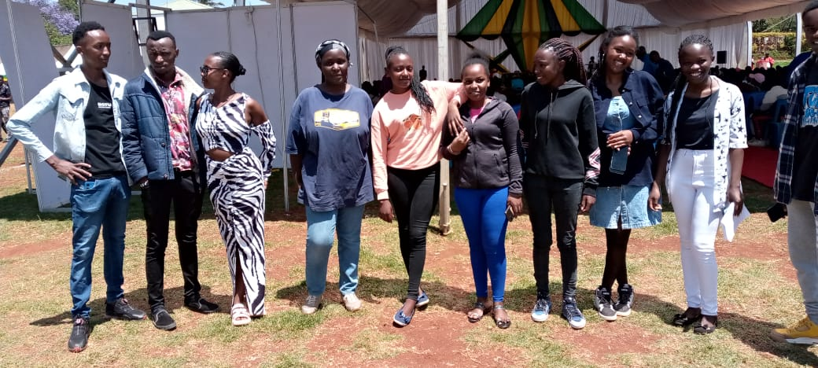

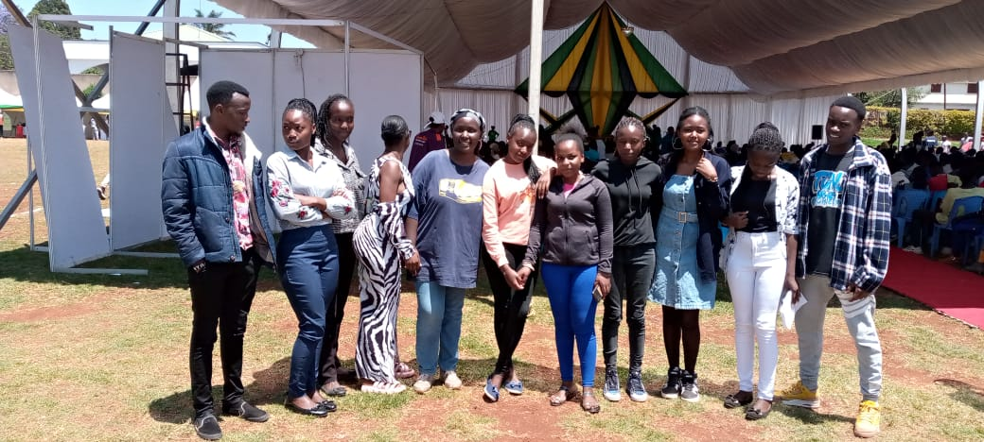

Several prominent organizations attended the event as recruiters, including Bingwa, Youth Enterprise Development Fund (YEDF), Multi Work Force Westlands, Skyways Global Services Ltd, Genesis Cruise Services, Red Arrow Agencies Ltd, Workster Consult Agency Ltd, Begem Consult Ltd, Alwaka Agency, Blue Wave International Ltd, and Monisa Company. These organizations aimed to bridge the employment gap by offering job opportunities and networking avenues, benefiting job seekers who sought both local and international employment prospects. In addition to providing direct access to job opportunities, the event hosted a Skills Competition that allowed participants to demonstrate their expertise in various fields. This added a competitive element to the fair, enabling job seekers to showcase their abilities and potentially stand out to employers actively looking for skilled candidates



The Nyeri Job Fair and Skills Competition 2024 was a substantial step towards promoting career success and skill development within the community. Through this collaborative effort, the Polytechnic and the Department of Gender, Youth, Sports, and Social Services demonstrated a strong commitment to improving employability and supporting youth and alumni as they pursue meaningful career opportunities

